Lab 13

Configuring NPS Policies

This lab contains the following exercises and activities:

|  |  |
| --- | --- |
| Exercise 13.1 | Creating and Configuring Connection Request Policies |
| Exercise 13.2 | Creating and Configuring Network Policies |
| Exercise 13.3 | Exporting and Importing the NPS Configuration |
| Lab Challenge | Processing Network Policies |

BEFORE YOU BEGIN

The lab environment consists of student workstations connected to a local area network, along with a server that functions as the domain controller for a domain called *contoso.com*. The computers required for this lab are listed in Table 13-1.

Table 13-1

Computers Required for Lab 13

|  |  |  |
| --- | --- | --- |
| Computer | Operating System | Computer Name |
| Server (VM 1) | Windows Server 2012 | RWDC01 |

In addition to the computers, you also require the software listed in Table 13-2 to complete Lab 13.

Table 13-2

Software Required for Lab 13

|  |  |
| --- | --- |
| Software | Location |
| Lab 13 student worksheet | Lab13_worksheet.rtf (provided by instructor) |

Working with Lab Worksheets

Each lab in this manual requires that you answer questions, take screen shots, and perform other activities that you will document in a worksheet named for the lab, such as Lab13_worksheet.rtf. You will find these worksheets on the book companion site. It is recommended that you use a USB flash drive to store your worksheets, so you can submit them to your instructor for review. As you perform the exercises in each lab, open the appropriate worksheet file using WordPad, fill in the required information, and save the file to your flash drive.

After completing this lab, you will be able to:

* Create and Configure connection request policies
* Create and Configure network policies
* Import and export the NPS configuration
* Understand how network policies are processed

Estimated lab time: 55 minutes

|  |  |
| --- | --- |
| Exercise 13.1 | Creating and Configuring Connection Request Policies |
| Overview | In this exercise, you start using NPS policies, specifically the Connection Request Policies. |
| Completion time | 15 minutes |

**Mindset Question: During this lab, you start using NPS Policies. What are connection request policies used for?**

**1.** Log in to RWDC01 as **Contoso\administrator** using the password **Password01**. The Server Manager console opens.

**2.** On Server Manager, click Tools > Network Policy Server. The Network Policy Server console opens.

**3.** Double-click Policies in the NPS tree.

|  |  |
| --- | --- |
| Question 1 | What does the default connection request policy do? |

**4.** Right-click Connection Request Policies, and then click New. The New Connection Request Policy Wizard starts.

**5.** In the Policy name text box, type **Connection Request Policy 1** in the Policy name text box.

**6.** Under Type of network access server, select *Remote Access Server (VPN-Dial up)*. Click Next.

**7.** Take a screen shot of the New Connection Request Policy window by pressing Alt+Prt Scr and then paste it into your Lab13_worksheet file in the page provided by pressing Ctrl+V.

**8.** On the Specify Conditions page, click Add.

**9.** When the Select condition dialog box opens, click Tunnel Type and click Add.

**10.** When the Tunnel Type dialog box opens, click *IP Encapsulating Security Payload in the Tunnel-mode (ESP)*, *Layer Two Tunneling Protocol (L2TP)*, and *Secure Socket Tunneling Protocol (SSTP)*. Click OK.

**11.** Click Add again, click Day and Time Restrictions, and click Add.

**12.** When the Day and time restrictions dialog box opens click Monday through Friday, 8 AM to 5 PM, and click Permitted. A blue box should appear as shown in Figure 13-1. Click OK.

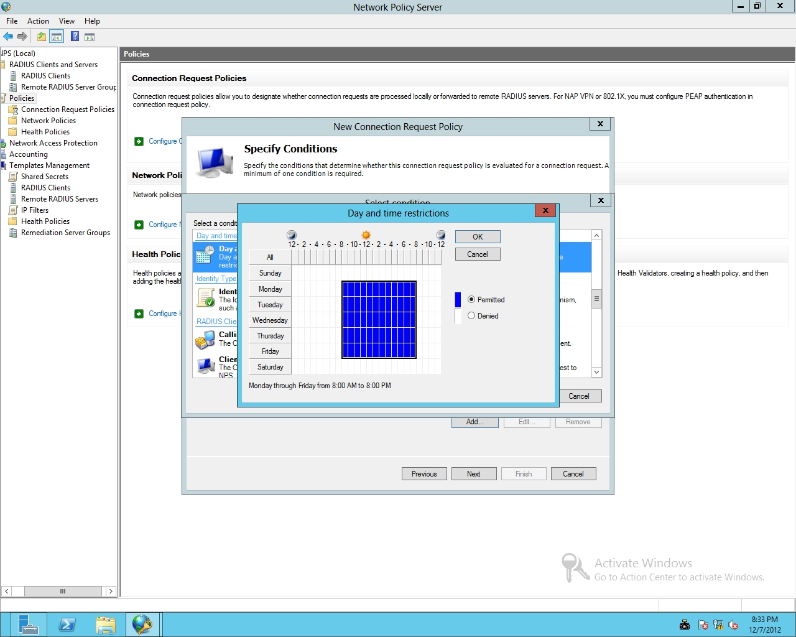

Figure 13-1

Restricting access by day and time

**13.** Back on the Specify Conditions page, click Next.

**14.** On the Specify Connection Request Forwarding page, click Next.

**15.** On the Specify Authentication Methods page, click Next.

**16.** On the Configure Settings page, click Next.

**17.** On the Completing Connection Request Policy Wizard page, click Finish. When created, the Connection Policy is listed in the Connection Request Policies pane.

**18.** Leave the Network Policy Server console open for the next exercise.

End of exercise. You can leave the windows open for the next exercise.

|  |  |
| --- | --- |
| Exercise 13.2 | Creating and Configuring Network Policies |
| Overview | During this exercise, you continue to use NPS policies by creating and configuring Network Policies. |
| Completion time | 10 minutes |

**Mindset Question: During this lab, you start using NPS Policies. What are network policies used for?**

**1.** On RWDC01, using the Network Policy Server, right-click Network Policies, and then click New. The New Network Policy Wizard opens as shown in Figure 13-2.

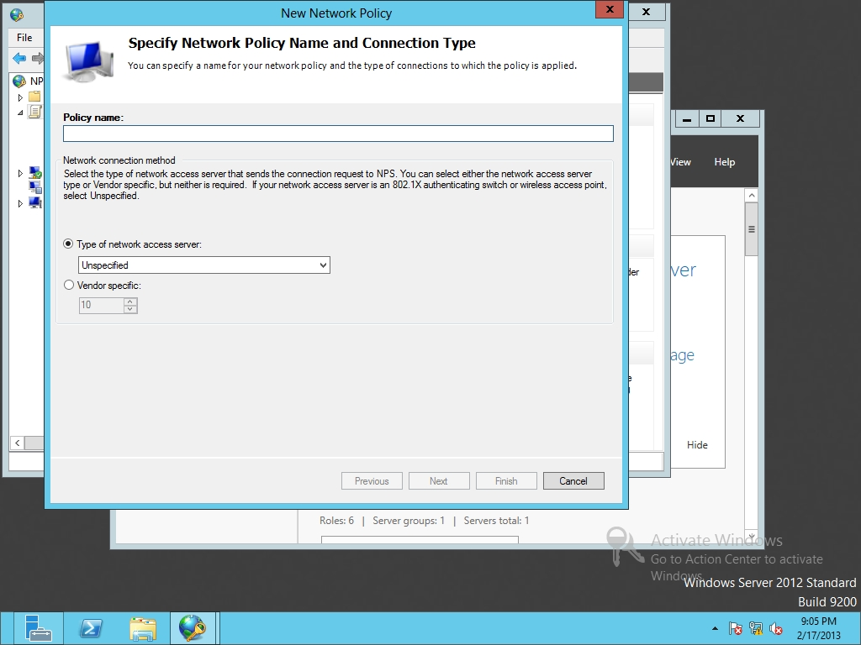

Figure 13-2

Creating a new network policy

**2.** In the Policy name text box, type **Network Policy 1** in the Policy name text box.

**3.** For the type of network access server, select *Remote Access Server (VPN-Dial up)*. Click Next.

|  |  |
| --- | --- |
| Question 2 | What are the three components that make up a NPS network policy? |

**4.** On the Specify Conditions page, click Add.

**5.** When the Select conditions dialog box opens, click Windows Groups and click Add.

**6.** Click Add Groups. In the Enter the object name to select text box, type **domain guests** and click OK. Click OK to close the Windows Groups dialog box. Click Next.

**7.** On the Specify Access Permission page, answer the following question, and click Next.

|  |  |
| --- | --- |
| Question 3 | What is the default access permission? |

**8.** On the Configure Authentication Methods page, take a screen shot by pressing Alt+Prt Scr and then paste it into your Lab13_worksheet file in the page provided by pressing Ctrl+V. Click Next.

**9.** On the Configure Constraints page, with Idle Timeout selected, select the *Disconnect after the maximum idle time*. Then specify 15 minutes. Click Next.

**10.** On the Configure Settings page, click Next.

**11.** On the Completing New Network Policy page, click Finish.

**12.** Click Network Policies under Policies on left side and observe that the new Network Policy 1 is listed in the Network Policies pane.

End of exercise. You can leave the windows open for the next exercise.

|  |  |
| --- | --- |
| Exercise 13.3 | Exporting and Importing the NPS Configuration |
| Overview | In the previous lab, you created and used NPS templates to help configure RADIUS. During this lesson, you export the configuration for the NPS server to an XML file and then import the configuration back into the system. |
| Completion time | 10 minutes |

**1.** On RWDC01, open a Command Prompt (Admin) window.

**2.** Type **netsh**, and then press Enter.

**3.** At the netsh prompt, type **nps**, and then press Enter.

**4.** At the netsh nps prompt, type **export filename="C:\Bak.xml" exportPSK=YES**. Press Enter.

|  |  |
| --- | --- |
| Question 4 | What does the warning say? |

**5.** At the command prompt, type **exit** and press Enter.

**6.** To import back in, type **netsh nps import filename="C:\Bak.xml"**, and then press Enter. A message appears indicating whether the import from the XML file was successful.

**7.** Take a screen shot of the Command Prompt window by pressing Alt+Prt Scr and then paste it into your Lab13_worksheet file in the page provided by pressing Ctrl+V.

**8.** When the import is complete, close the Administrator: command prompt and close the Network Policy console.

Lab REview Questions

|  |  |
| --- | --- |
| **Completion time** | **10 minutes** |

**1.** In Exercise 13.1, if you want to configure a RADIUS proxy and forward connection requests to another NPS or RADIUS server, what must you do?

**2.** In Exercise 13.1, when you create a connection request policy, what parameters do you configure?

**3.** In Exercise 13.2, if you had multiple network policies, why does order matter?

**4.** In Exercise 13.2, where would you configure multilink and bandwidth allocation?

|  |  |
| --- | --- |
| Lab Challenge | Processing Network Policies |
| Overview | To complete this challenge, you will describe hohw network policies are processed by writing the high-level steps of processing network policies. |
| Completion time | 10 minutes |

During this lab, you started to use NPS policies, specifically the Connection Request policies and Network Policies. Although the connection request policy specified settings for the RADIUS server, the network policy will allow or disallow the remote access.

What are the steps used when processing network policies?

End of lab. You can log off or start a different lab. If you want to restart this lab, you’ll need to click the End Lab button in order for the lab to be reset.